Telegram Backed Hybrid Cloud Storage Management System
Data Flow Diagram (DFD)

LEVEL 0:
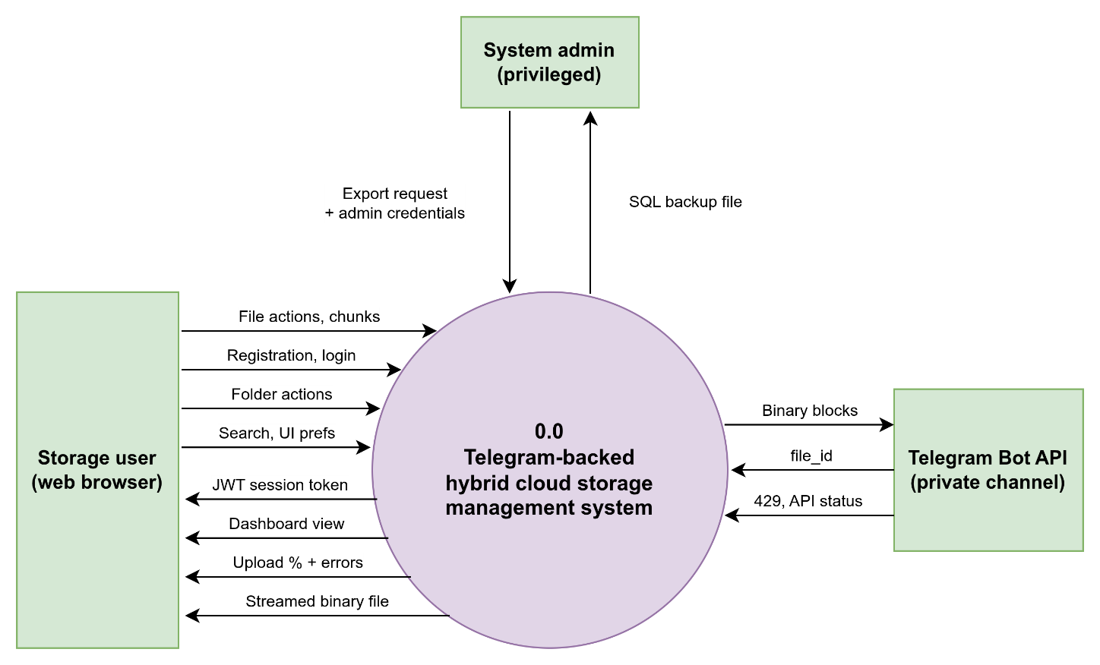

LEVEL 1:
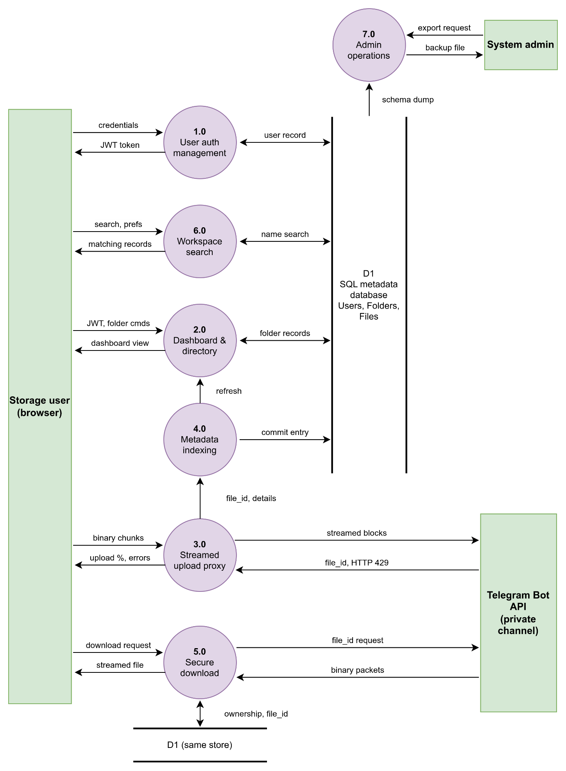

LEVEL 2:
